Supplementary Information

3.2 Dataset Description

This research utilizes an anonymized cross-institutional digital academic credential dataset consisting of 1,724 credential records. The dataset contains structured academic information representing essential components of digital credentials, including institution identity, academic program, education level, accreditation status, academic performance, graduation information, and credential classification labels. The dataset includes 11 attributes describing credential characteristics and semantic relationships among academic entities.
The dataset characteristics are presented in Table 1

Table 1. Dataset Characteristics
Characteristics | Description
Dataset type | Anonymized cross-institutional academic credential dataset
Total records | 1,724
Total attributes | 11
Institutions | 2
Classification task | Credential consistency assessment
Label 1 | Consistent credential (862 records, 50%)
Label 0 | Inconsistent credential (862 records, 50%)
Duplicate records | None detected
Main attributes | Institution, program, education level, accreditation status, GPA, graduation information
The dataset contains a balanced distribution between consistent and inconsistent credential records, with 862 records assigned to each class. This balanced distribution minimizes potential bias toward a dominant class during classification model development. The dataset includes categorical and numerical attributes representing academic credential information. These attributes are used as the basis for conventional attribute representation and further processed to construct semantic knowledge features representing relationships among academic attributes..
Table 2: Dataset Attributes.
Attribute | Type | Description
Credential ID | Identifier | Unique credential record identifier
Institution | Categorical | Issuing academic institution
Program | Categorical | Academic program associated with the credential
Education Level | Categorical | Academic qualification level
Accreditation Status | Categorical | Accreditation category of the academic program
GPA | Numerical | Academic performance indicator
Graduation Predicate | Categorical | Graduation achievement category
Graduation Date | Categorical/Date | Credential completion information
Faculty/Program Name | Categorical | Faculty or academic unit associated with the program
Label | Binary | Credential consistency class
Manipulation Type | Categorical | Type of semantic inconsistency introduced or detected

3.3 Data Preprocessing and Semantic Feature Representation
The first preprocessing step involved separating the predictor variables from the target variable. In this study, the target variable represents credential consistency, consisting of two classes: semantically consistent credentials (label = 1) and semantically inconsistent credentials (label = 0). To prevent information leakage, Credential ID, the target Label, and Manipulation Type were excluded from the predictor set. Credential ID was retained only as a record identifier, Label was used exclusively as the target variable, and Manipulation Type was retained only for descriptive and audit purposes. None of these three variables were used during feature construction, model training, cross-validation, or performance evaluation.
The predictor set therefore consisted only of credential attributes relevant to academic consistency assessment, including institution identity, academic program, education level, accreditation status, academic performance, graduation-related information, and other structured academic attributes.
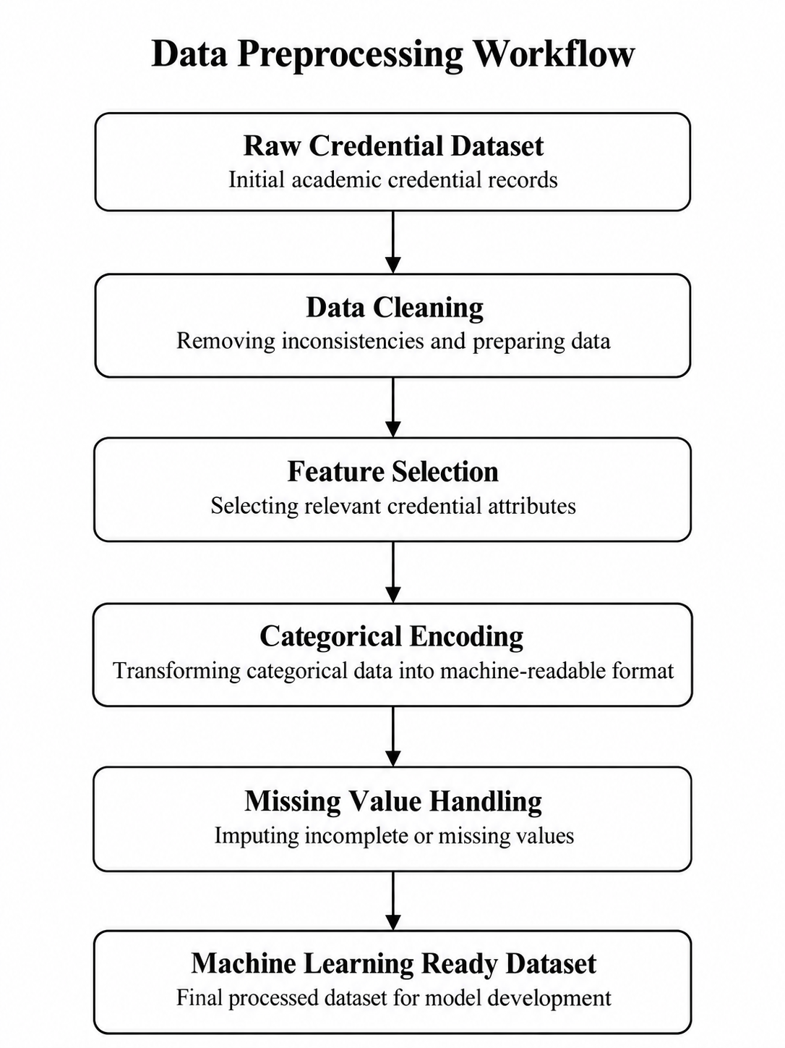
Figure 2 Data Preprocessing Workflow

3. 4 Semantic Knowledge Feature Construction
Semantic knowledge features were constructed to explicitly represent domain-specific relationships among academic credential attributes. Unlike conventional attribute-based representation, which treats credential elements primarily as independent input variables, the proposed semantic representation captures relationships among institutional identity, academic program, education level, and accreditation status. Four relationship-aware features were constructed: Institution–Program Consistency, Program–Level Compatibility, Program–Accreditation Alignment, and Academic Consistency Score. These features were subsequently combined with the conventional credential attributes to form the semantic knowledge-enhanced representation used in Experiment B..
Table 3, Semantic Knowledge Feature Representation
Semantic Feature | Related Attributes | Description
Institution–Program Consistency | Institution, Academic Program | Represents whether the academic program is compatible with the issuing institution according to the defined academic relationship rules.
Program–Level Compatibility | Academic Program, Education Level | Represents whether the academic program is compatible with the corresponding education or qualification level.
Program–Accreditation Alignment | Academic Program, Accreditation Status | Represents whether the accreditation information is appropriately aligned with the corresponding academic program.
Academic Consistency Score | Institution, Academic Program, Education Level, Accreditation Status | Provides an aggregated representation of the overall semantic consistency among interconnected academic credential attributes.
Table 3 summarizes the semantic knowledge features constructed from the relationships among digital academic credential attributes. These features are designed to represent higher-level academic consistency patterns that cannot be directly captured through individual credential attributes. The construction process incorporates domain knowledge regarding the logical relationships between institutional information, academic programs, education levels, and accreditation status.
The Institution-Program Consistency feature represents the compatibility between the issuing institution and the registered academic program. This feature helps identify cases where a credential contains an academic program that is inconsistent with the institution profile. The Program-Level Compatibility feature evaluates whether the academic program corresponds to the appropriate education level, while the Program-Accreditation Alignment feature captures the relationship between academic programs and their accreditation status.
Furthermore, the Academic Consistency Score provides an aggregated representation of multiple semantic relationships among credential attributes. This feature summarizes the overall consistency level of a credential record and enables machine learning models to utilize domain-specific knowledge during classification. The generated semantic features are subsequently combined with the original credential attributes to form the semantic knowledge enhanced representation used in Experiment B.
By incorporating these semantic representations, the proposed approach extends conventional attribute-based classification by enabling models to consider relationships among credential components. The comparison between Experiment A and Experiment B is then used to evaluate whether semantic knowledge enhancement improves the capability of machine learning models in distinguishing valid and invalid digital academic credentials.
Feature-Space Composition of Experiment B
Following preprocessing and categorical encoding, the semantic knowledge-enhanced representation used in Experiment B consisted of 49 machine-readable predictor features. Seven conventional categorical credential attributes were transformed using one-hot encoding, producing 44 encoded features: institution (2 features), academic program (14), education level (4), accreditation status (3), graduation predicate (4), graduation date (3), and faculty/program name (14). GPA was retained as one numerical predictor, resulting in 45 conventional machine-readable features. Four additional semantic relationship features—Institution–Program Consistency, Program–Level Compatibility, Program–Accreditation Alignment, and Academic Consistency Score—were subsequently incorporated, producing a final Experiment B feature space of 49 predictors.
Table 4. Composition of the Experiment B Feature Space
Feature Group | Source Attribute | Transformation | Number of Features
Institution | Institution | One-hot encoding | 2
Academic Program | Program | One-hot encoding | 14
Education Level | Education Level | One-hot encoding | 4
Accreditation Status | Accreditation Status | One-hot encoding | 3
Graduation Predicate | Graduation Predicate | One-hot encoding | 4
Graduation Date | Graduation Date | One-hot encoding | 3
Faculty/Program Name | Faculty/Program Name | One-hot encoding | 14
Academic Performance | GPA | Numerical | 1
Institution–Program Consistency | Institution + Program | Binary semantic feature | 1
Program–Level Compatibility | Program + Education Level | Binary semantic feature | 1
Program–Accreditation Alignment | Program + Accreditation Status | Binary semantic feature | 1
Academic Consistency Score | Multiple academic relationships | Numerical semantic feature | 1
Total | — | — | 49

3.5 Experimental Design (Experiment A and Experiment B)
To investigate the contribution of semantic knowledge representation in digital academic credential consistency assessment, this study designed two primary experimental settings: Experiment A (Baseline Credential Attribute Model) and Experiment B (Semantic Knowledge-Enhanced Model). Both experiments use the same anonymized dataset, preprocessing procedures, machine learning algorithms, and evaluation metrics to ensure a fair comparison. The primary difference between the two experiments is the feature representation provided to the classification models.

Experiment A: Baseline Credential Attribute Model
Experiment A represents the baseline condition, where machine learning models are trained using conventional credential attribute representation. In this setting, the models utilize the original academic credential attributes without explicitly incorporating semantic relationships among credential components. The input representation consists of structured credential attributes describing institutional information, academic programs, education level, accreditation status, academic performance, and graduation-related information.
This experiment establishes the baseline capability of supervised machine learning models in assessing credential consistency based on attribute-level information. The results from Experiment A provide a reference point for measuring the additional contribution obtained from semantic knowledge-enhanced representation.
Experiment B: Semantic Knowledge Enhanced Model
Experiment B extends the baseline approach by incorporating semantic knowledge features constructed from relationships among academic credential attributes. In this setting, conventional credential attributes are combined with relationship-aware features representing semantic consistency patterns among interconnected academic entities.
The semantic-enhanced representation captures domain-specific relationships, including institution-program consistency, program-education level compatibility, accreditation alignment, and overall academic attribute consistency. By incorporating these semantic relationships into the feature space, Experiment B evaluates whether domain knowledge representation provides additional discriminative information for identifying consistent and inconsistent credential records.

Generalization Evaluation
In addition to the primary comparison between baseline and semantic-enhanced representations, this study performs additional generalization evaluations to examine model robustness under more challenging testing scenarios.
Semantic Group Generalization Evaluation
The semantic group generalization evaluation investigates whether the developed models maintain performance when evaluated on credential patterns that differ from those observed during training. This evaluation reduces the possibility of overly optimistic results caused by similar credential structures appearing in both training and testing data.
Cross-Institution Transfer Evaluation
The cross-institution transfer evaluation examines the ability of trained models to generalize across heterogeneous institutional environments. In this setting, models are trained using credential records from one institution and evaluated using records from another institution. This experiment assesses whether semantic knowledge representation can improve robustness when applied to unseen institutional contexts.
Model and Evaluation Consistency
All experimental settings employ the same machine learning algorithms, including Logistic Regression, Decision Tree, Support Vector Machine (SVM), and Random Forest. Model performance is evaluated using accuracy, precision, recall, F1-score, and ROC-AUC. Comparative analysis between baseline and semantic-enhanced models is conducted to quantify the contribution of semantic knowledge representation, while additional generalization experiments provide insights into model robustness beyond conventional random validation.
Table 4 A. Experimental Design Comparison
Component | Experiment A: Baseline Credential Attribute Model | Experiment B: Semantic Knowledge-Enhanced Model
Feature representation | Original credential attribute representation | Original credential attributes combined with semantic knowledge features
Semantic relationship modeling | Not explicitly applied | Applied through relationship-aware feature construction
Input features | Conventional credential attributes | Credential attributes + semantic relationship features
Semantic features | Not included | Institution-program consistency, program-level compatibility, accreditation alignment, academic consistency score
Machine learning algorithms | Logistic Regression, Decision Tree, SVM, Random Forest | Logistic Regression, Decision Tree, SVM, Random Forest
Classification objective | Assess credential consistency based on attribute-level information | Assess credential consistency using attribute and semantic relationship information
Purpose | Establish baseline performance | Evaluate contribution of semantic knowledge representation

Table 5. Generalization Evaluation Strategy
Evaluation Setting | Training Data | Testing Data | Purpose
Semantic Group Generalization | Credential groups from training partition | Unseen semantic credential groups | Evaluate robustness toward unseen credential patterns
Cross-Institution Transfer | One institution credential records | Different institution credential records | Evaluate transferability across institutional environments

3.6 Machine Learning Models
This study employs four supervised machine learning algorithms to evaluate the effectiveness of baseline and semantic knowledge enhanced representations for digital academic credential consistency assessment. The selected algorithms include Logistic Regression, Decision Tree, Support Vector Machine (SVM), and Random Forest. These algorithms were selected because they represent different learning approaches, including linear classification, rule-based classification, margin-based classification, and ensemble learning.
All machine learning models were implemented under the same experimental conditions for both Experiment A and Experiment B. The use of identical algorithms allows the observed performance differences to be attributed primarily to the effect of feature representation rather than differences in model architecture.

3.6.1 Logistic Regression
Logistic Regression is a statistical classification algorithm commonly used for binary classification problems. The model estimates the probability of an observation belonging to a particular class based on a weighted combination of input features. In this study, Logistic Regression is used to evaluate whether semantic knowledge features improve the capability of a linear classifier in distinguishing valid and invalid digital academic credentials.

3.6.2 Decision Tree
Decision Tree is a supervised learning algorithm that performs classification through a hierarchical decision structure. The algorithm divides data based on feature conditions to generate decision rules for classification. Decision Tree is suitable for credential assessment because it can represent relationships among categorical and numerical attributes in an interpretable manner.

3.6.3 Support Vector Machine (SVM)
Support Vector Machine is a classification algorithm that identifies an optimal decision boundary between classes by maximizing the margin between observations. SVM is effective for high-dimensional feature spaces and is commonly applied in classification problems involving complex feature representations. In this research, SVM is evaluated to determine whether semantic knowledge features improve class separation between valid and invalid credential records.

3.6.4 Random Forest
Random Forest is an ensemble learning algorithm introduced by Breiman (2001) that combines multiple decision trees to improve classification performance and reduce overfitting. The algorithm is capable of capturing nonlinear relationships and interactions among heterogeneous features. Therefore, Random Forest is suitable for evaluating credential datasets containing multiple academic attributes and semantic relationship features.
Table 6. Machine Learning Algorithms Used in This Study
Algorithm | Learning Approach | Characteristics
Logistic Regression | Linear classifier | Interpretable binary classification
Decision Tree | Rule-based classifier | Captures feature-based decision patterns
Support Vector Machine | Margin-based classifier | Effective in high-dimensional spaces
Random Forest | Ensemble classifier | Handles nonlinear relationships and feature interactions

3.7 Evaluation Metrics
The performance of the proposed machine learning models was evaluated using multiple classification metrics to provide a comprehensive assessment of digital academic credential consistency classification. Since the task is formulated as a binary classification problem, credential records are categorized as valid credentials (label = 1) and invalid credentials (label = 0). Accordingly, the evaluation measures the ability of each model to distinguish between valid and invalid credential records. The evaluation metrics used in this study include accuracy, precision, recall, F1-score, ROC-AUC, and five-fold stratified cross-validation F1-score. These complementary metrics were selected because accuracy alone may not provide a complete representation of classification performance, particularly when different types of prediction errors are considered..
Accuracy
Accuracy measures the proportion of correctly classified credential records among all evaluated samples. It provides an overall measurement of classification effectiveness.
$$Accuracy=\frac{TP+TN}{TP+TN+FP+FN}​$$
where TP represents true positive predictions, TN represents true negative predictions, FP represents false positive predictions, and FN represents false negative predictions.
Precision
Precision measures the proportion of correctly identified valid credentials among all records predicted as valid.
$$Precision=\frac{TP}{TP+FP}​$$
A higher precision value indicates that the model produces fewer false positive classifications.
Recall
Recall measures the ability of the model to correctly identify actual positive samples. This metric is important because failure to identify valid credentials may reduce the reliability of automated credential assessment.
$$Recall=\frac{TP}{TP+FN}​$$
A higher recall value indicates that the model can capture more relevant credential records.
F1-score
The F1-score represents the harmonic mean of precision and recall and provides a balanced measure when both false-positive and false-negative errors are relevant.
$$F1=2 =\frac{Precision×Recall}{Precision+ Recal}$$
In this study, the F1-score is used as the primary metric for comparing Experiment A and Experiment B because it simultaneously reflects the model's precision and recall performance.

ROC-UC

The Receiver Operating Characteristic Area Under the Curve (ROC-AUC) measures the ability of a classifier to discriminate between valid and invalid credential records across different classification thresholds. ROC-AUC values closer to 1 indicate stronger discrimination capability, while values closer to 0.5 indicate limited class-separation ability.

Stratified Cross-Validation
To evaluate model robustness and reduce dependence on a single train-test split, five-fold stratified cross-validation was applied. Stratification preserves the original class distribution within each fold. The F1-score was calculated for each validation fold, and both the mean F1-score and its standard deviation were reported to assess average performance and variation across folds. The same evaluation procedure was applied to both Experiment A and Experiment B. This consistent evaluation design enables a direct comparison between the baseline credential representation and the semantic knowledge enhanced representation, allowing the contribution of semantic features to be assessed under equivalent experimental conditions.
Table 7. Evaluation Metrics Used in This Study
Metric | Purpose
Accuracy | Measures overall classification correctness
Precision | Measures the correctness of valid-credential predictions
Recall | Measures the ability to identify actual valid credentials
F1-score | Provides a balanced measure of precision and recall
ROC-AUC | Measures discrimination capability between valid and invalid credentials
CV F1 Mean | Measures average F1 performance across five stratified folds
CV F1 Standard Deviation | Measures variation of F1 performance across validation folds

3.8 Feature Importance and Ablation Analysis
To complement the predictive performance evaluation, this study performs feature importance analysis and feature ablation experiments to investigate the contribution of individual credential attributes and semantic information to the classification process. These analyses are intended to provide additional insight into which academic features contribute most strongly to credential consistency assessment and to determine how model performance changes when selected information is removed.

3.8.1 Feature Importance Analysis
Feature importance analysis was conducted to identify the relative contribution of input features to the classification decisions. In particular, tree-based models provide importance scores that indicate how strongly individual features contribute to the construction of classification rules. The analysis focuses on identifying whether attributes related to academic program, education level, accreditation status, institutional information, and semantic consistency relationships contribute substantially to credential classification.
The feature importance scores were ranked to identify the most influential variables within the semantic knowledge enhanced representation. This analysis provides an interpretable view of the model by showing which credential attributes are most frequently used to distinguish valid and invalid records. However, feature importance values are interpreted as indicators of predictive contribution rather than causal relationships.
For categorical variables transformed through one-hot encoding, the resulting encoded components are evaluated according to their individual importance values. Features originating from the same academic attribute can subsequently be interpreted as representing the broader contribution of that credential information category.

3.8.2 Feature Ablation Analysis
Feature ablation analysis was conducted to further evaluate whether specific academic attributes provide meaningful information for credential consistency assessment. Unlike feature importance analysis, which measures the relative contribution of features within a trained model, ablation analysis evaluates the effect of systematically removing selected feature groups and retraining the classification model. The full feature configuration serves as the reference condition. Selected credential attributes are then removed individually, and model performance is recalculated using the same evaluation procedure. The reduction in classification performance relative to the full model provides an indication of the information contributed by the removed feature group.
The ablation configurations used in this study are summarized in Table 8.
Table 8. Feature Ablation Configurations
Configuration | Feature Condition | Purpose
Full Model | All selected credential attributes and semantic features are included | Establishes the reference performance of the complete feature representation
Without Program | Academic program information is removed | Evaluates the contribution of academic program information
Without Accreditation | Accreditation-related information is removed | Evaluates the contribution of accreditation information
Without Education Level | Education-level information is removed | Evaluates the contribution of qualification-level information
Numerical Only | Only numerical credential attributes are retained | Evaluates whether numerical information alone provides sufficient discriminative information for credential consistency assessment
The combination of feature importance and ablation analysis enables the proposed framework to evaluate not only whether semantic knowledge enhancement improves predictive performance, but also which academic attributes contribute to that improvement. This is particularly important for digital credential assessment because the objective is not merely to obtain high classification accuracy, but also to understand how relationships among academic attributes support automated consistency validation. The ablation experiments were evaluated using the same classification metrics employed in the main experiments, particularly accuracy and F1-score. A substantial performance decrease after removing a particular feature group indicates that the corresponding information contributes meaningful discriminative information to credential consistency assessment. Feature importance and ablation analysis therefore provide complementary perspectives. Feature importance identifies which variables receive greater predictive weight within the model, while ablation analysis evaluates whether removing specific credential information causes measurable performance degradation. Together, these analyses strengthen the interpretation of the semantic knowledge enhanced framework beyond overall classification performance.
Explicit Unknown Relationship Representation
An additional representation ablation was performed to examine whether explicitly distinguishing previously observed positive semantic relationships from unknown relationships could improve generalization. The experiment compared the baseline representation (Experiment A), the original training-derived semantic representation (Experiment B), and an explicit unknown representation (Experiment C). Under paired holdout evaluation, Experiment C achieved F1-scores of 0.9802, 1.0000, 0.9858, and 1.0000 for Logistic Regression, Decision Tree, SVM, and Random Forest, respectively. These results were comparable to, but did not improve upon, the corresponding Experiment B results. Under strict unseen semantic tuple evaluation and both cross-institutional transfer directions, all four classifiers achieved an F1-score of 0.0000 across the three representations. The explicit unknown representation therefore did not resolve the observed positive-class recognition failures in the evaluated out-of-distribution settings. The findings indicate that making unknown relationships explicit is insufficient when the underlying semantic reference is restricted to observed positive training relationships. Reliable cross-institutional assessment may require independently validated academic knowledge sources or additional mechanisms for interpreting relationships that are absent from the training data.

